JavaScript Syntax and Operators

Zawartość

Switch 2

For in and For of 3

Using Math and Comparison Operators 5

Working with Logical Operators 7

Utilizing JavaScript Exception Handling 8

Determining JavaScript variable type;\ 9

Magic of ‘THIS’ 9

Spread operator 10

## Switch

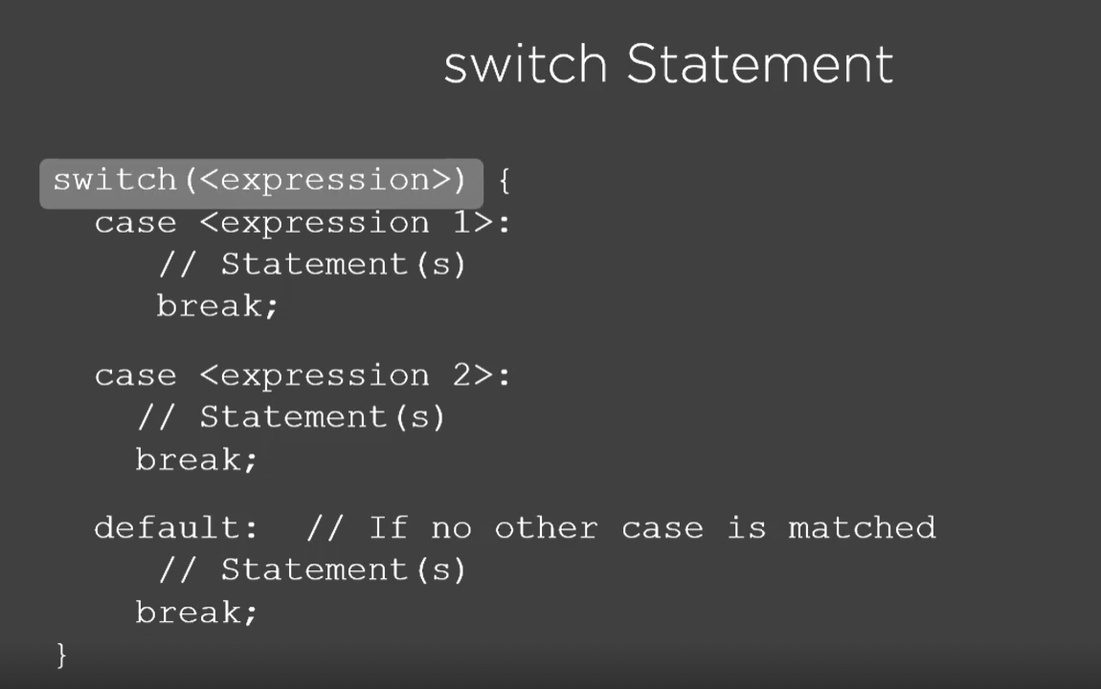

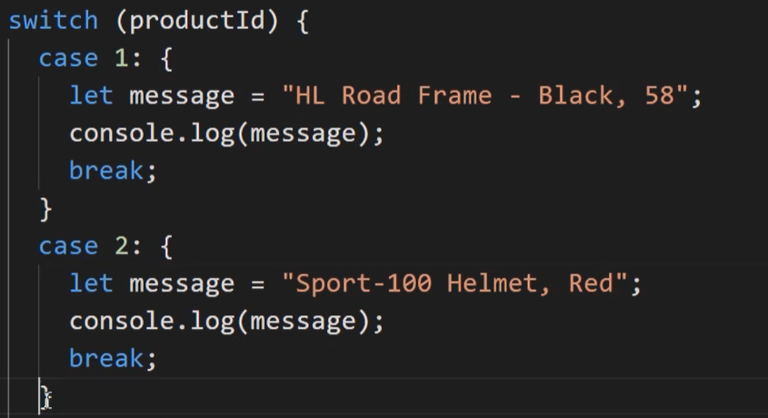

Switch statement by default is not a code block. So if you want to create some var in case scope use {} and create code block.

## For in and For of

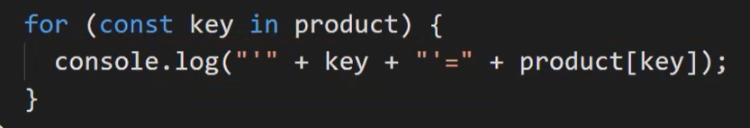

[**for in**](https://developer.mozilla.org/en-US/docs/Web/JavaScript/Reference/Statements/for...in) loops over enumerable property names of an object.

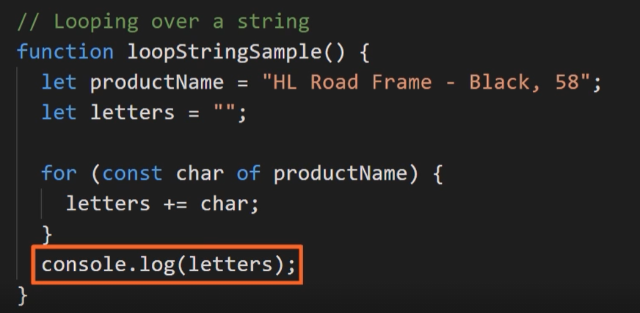

[**for of**](https://developer.mozilla.org/en-US/docs/Web/JavaScript/Reference/Statements/for...of) (new in ES6) does use an [object-specific *iterator*](https://developer.mozilla.org/en-US/docs/Web/JavaScript/Reference/Iteration_protocols) and loops over the values generated by that.

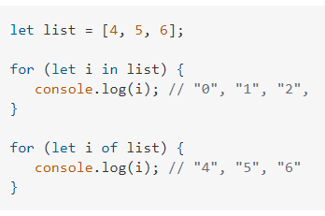

For in retun a key

For of return value

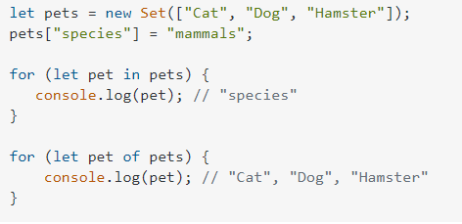

For In – in object example return key to property. However for of return value from set.

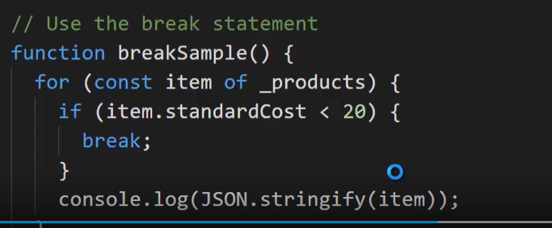

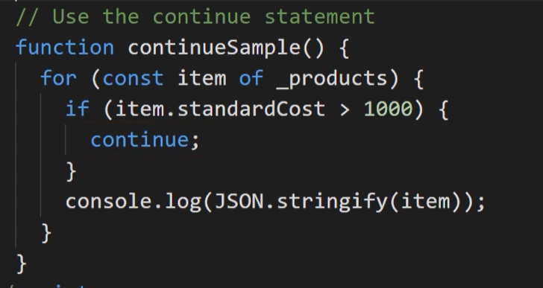

Break and continue works in the same way like in other programming languages.

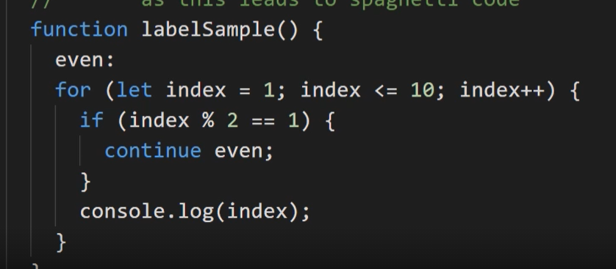

Label statement works in the same way like goto in C# so don’t use it.

## Using Math and Comparison Operators

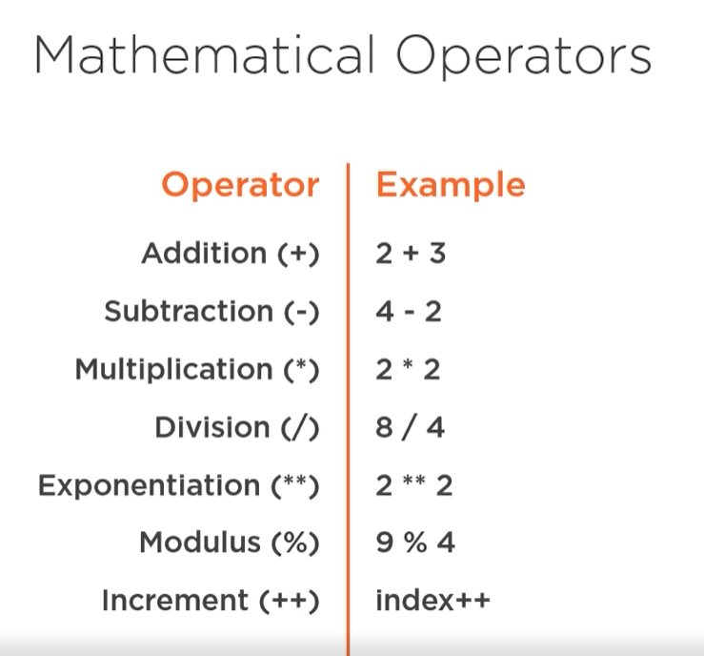

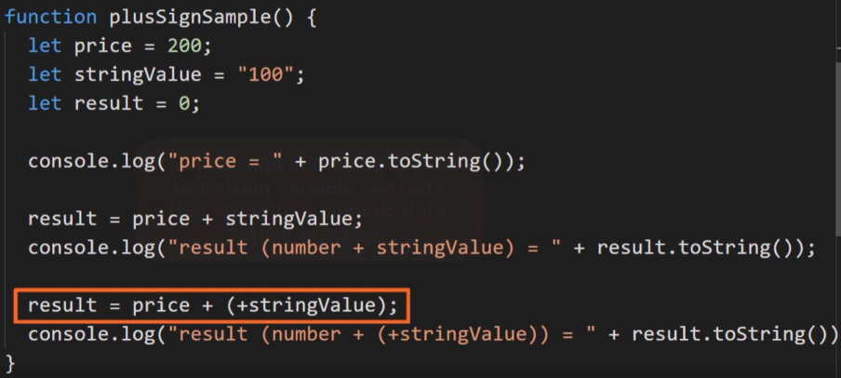

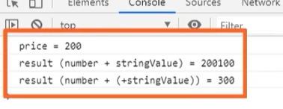

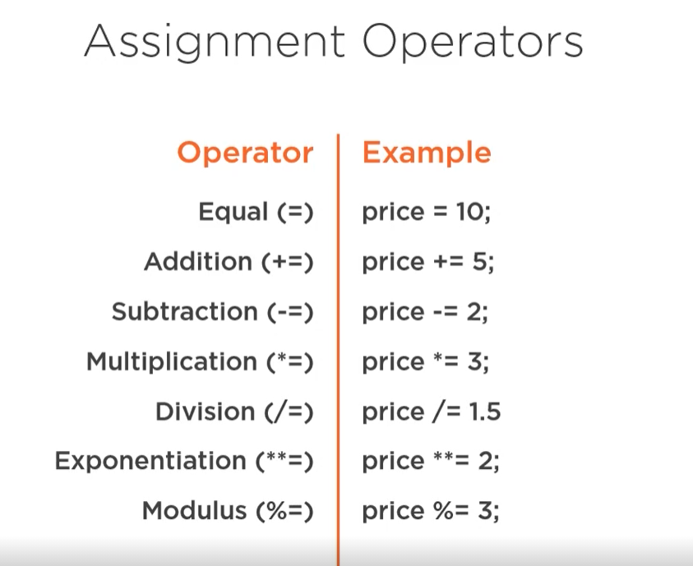

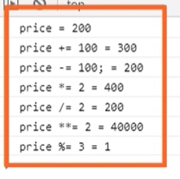

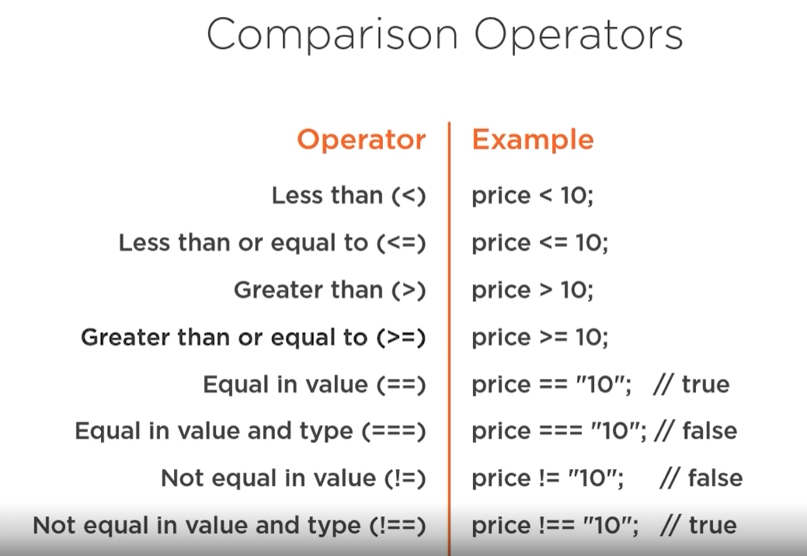

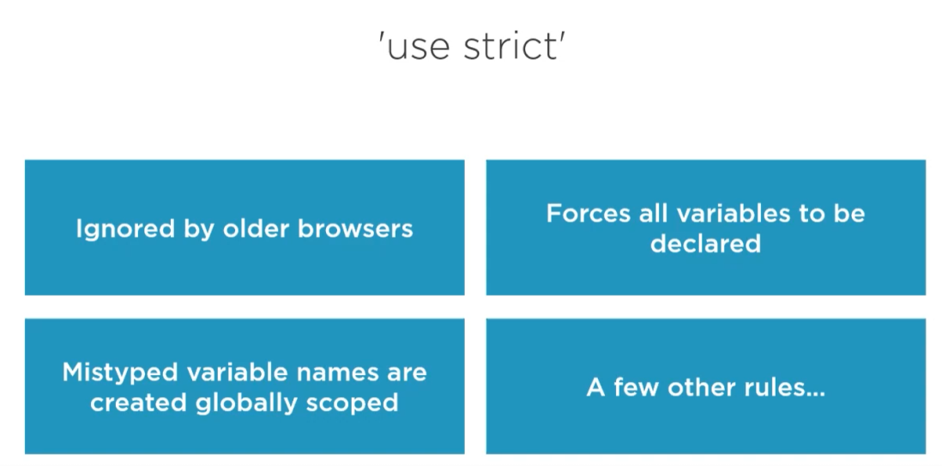

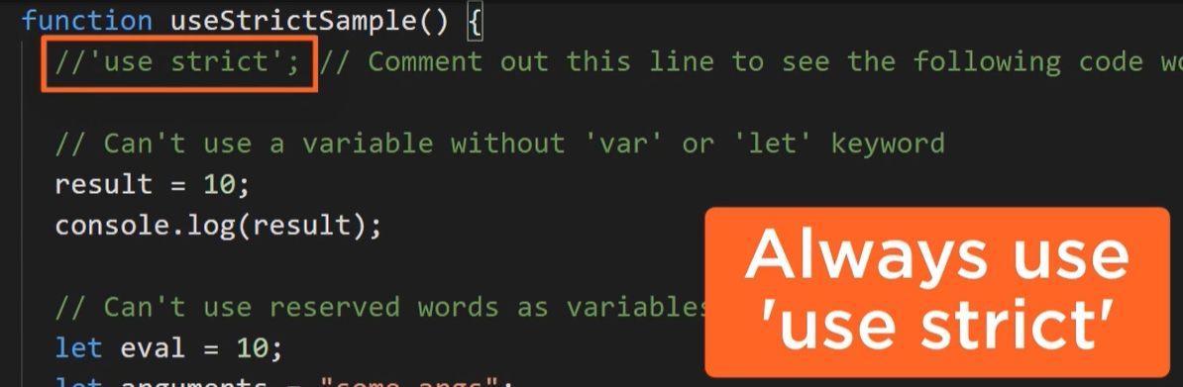

## Working with Logical Operators

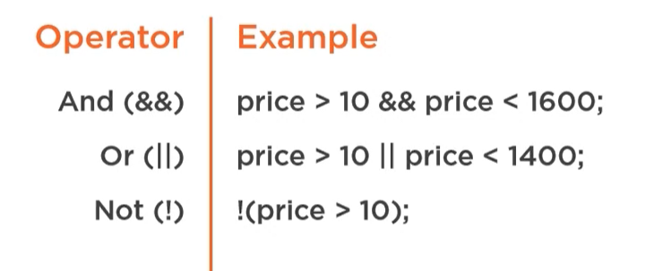

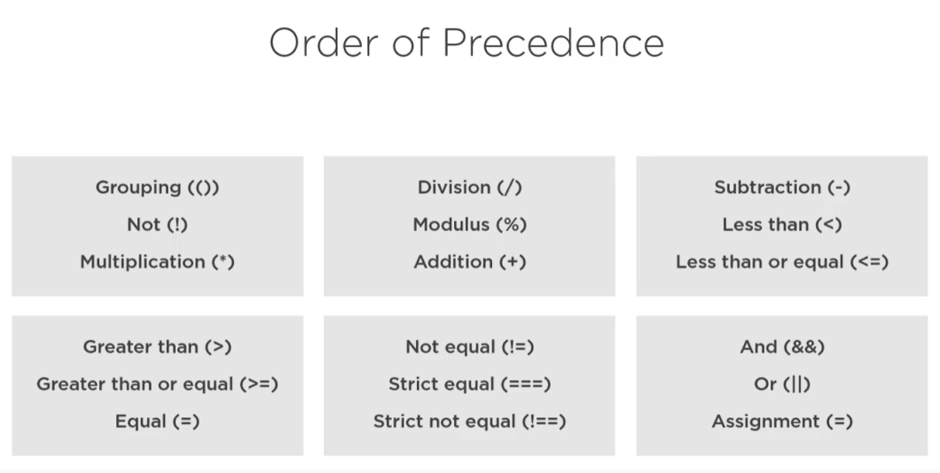

## Utilizing JavaScript Exception Handling

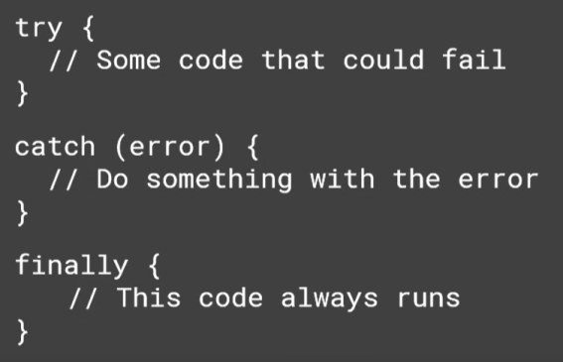

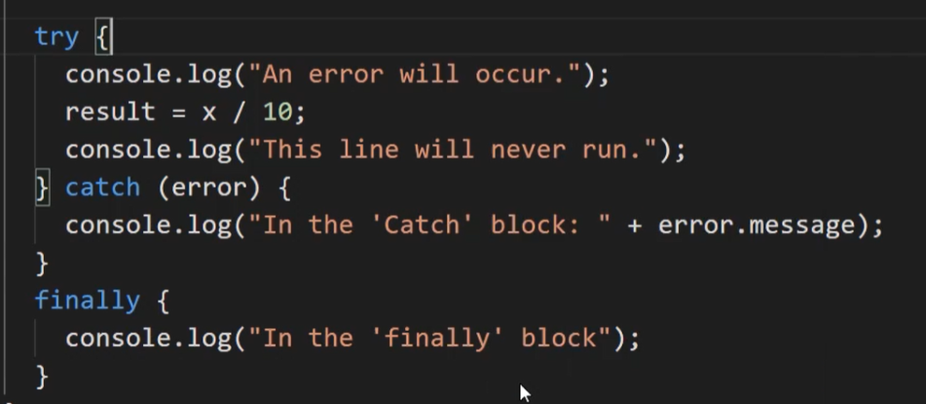

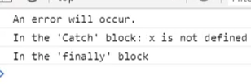

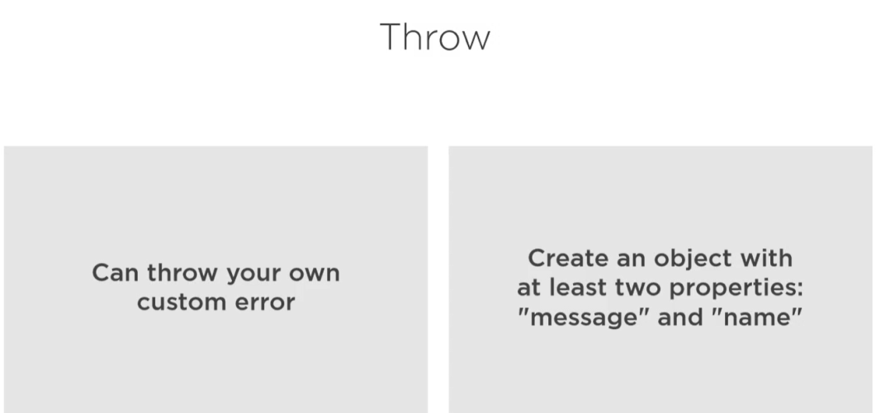

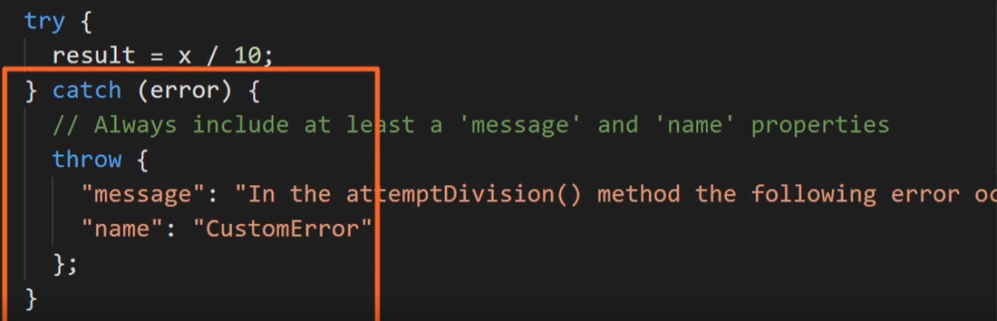

## Determining JavaScript variable type;\

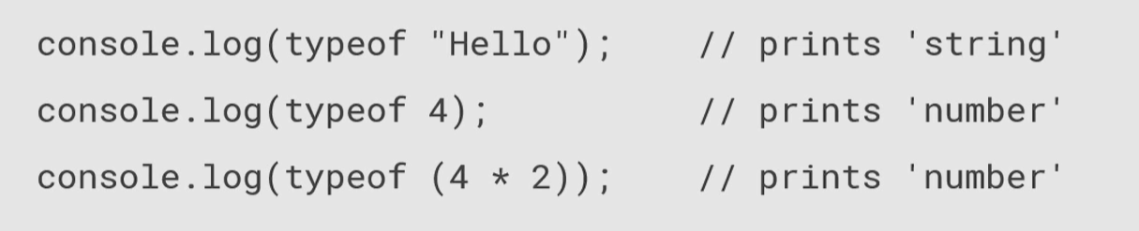

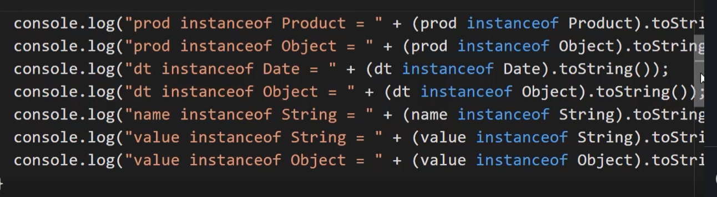

We can check that value is a instance of object

## Magic of ‘THIS’

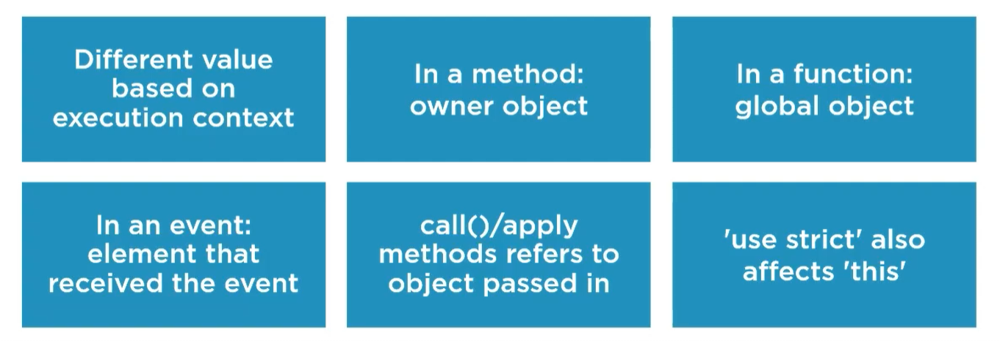

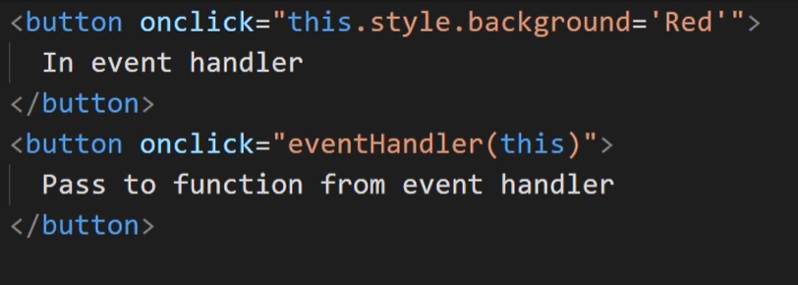

It can be use in event handler when we need to invoke particular operations on this object passed.

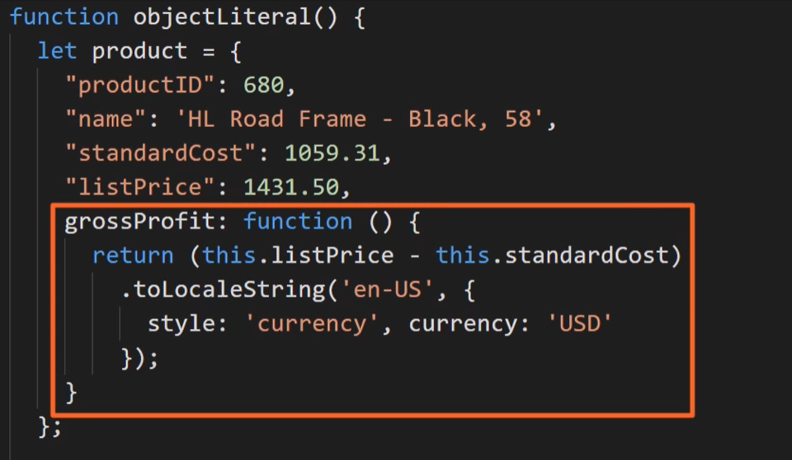

This has a scope and refer to neares code block. An example class scope.

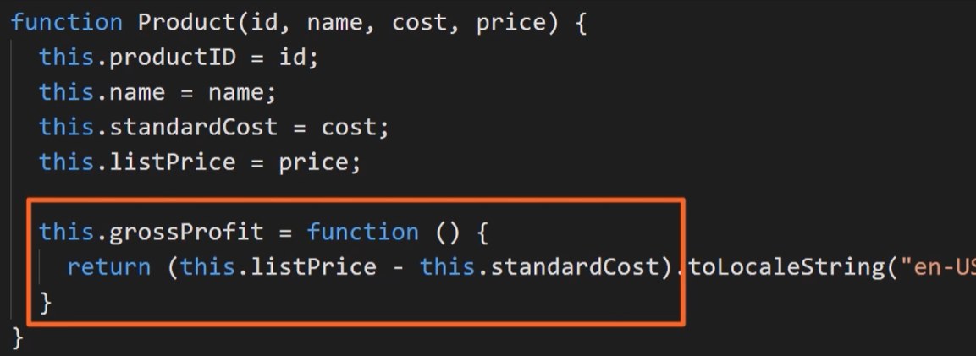

Another example.

## Spread operator

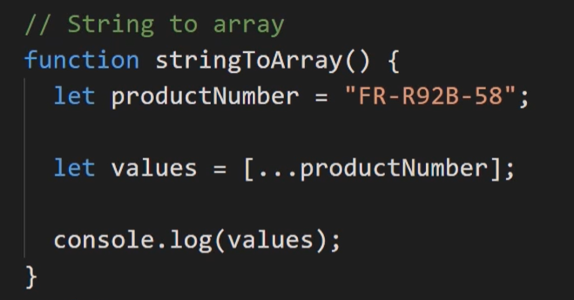

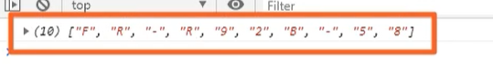

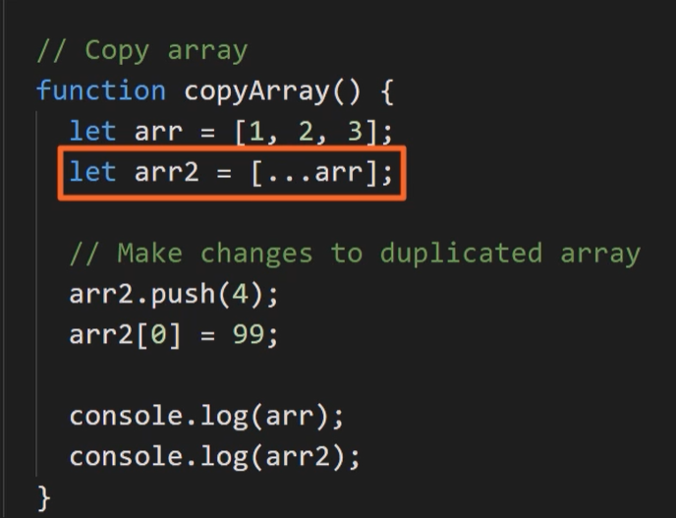

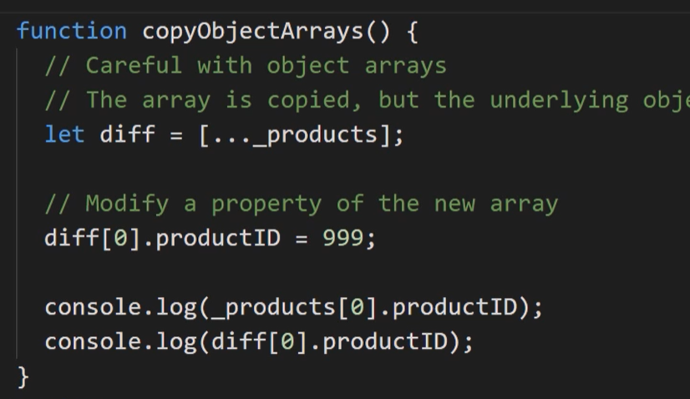

You can copy array of objects to next arr but remember this is a reference type.

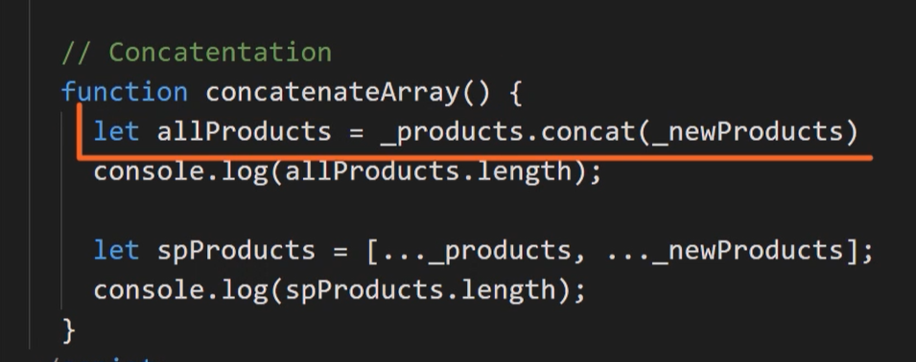

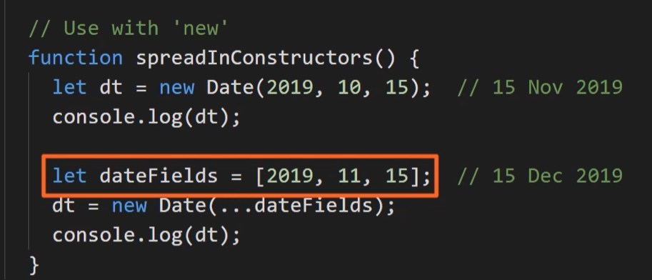

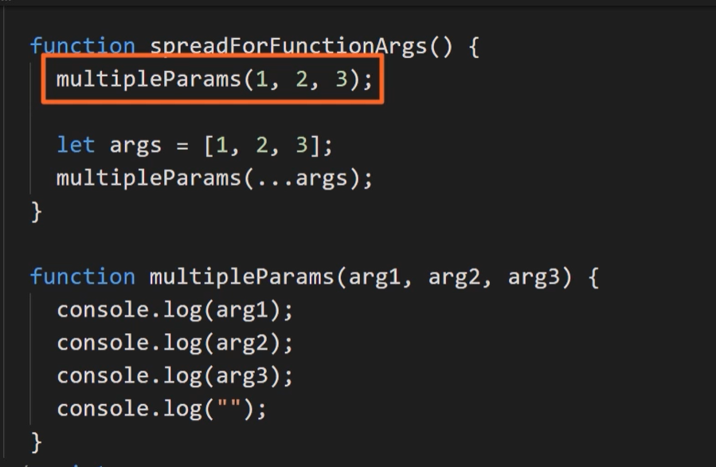

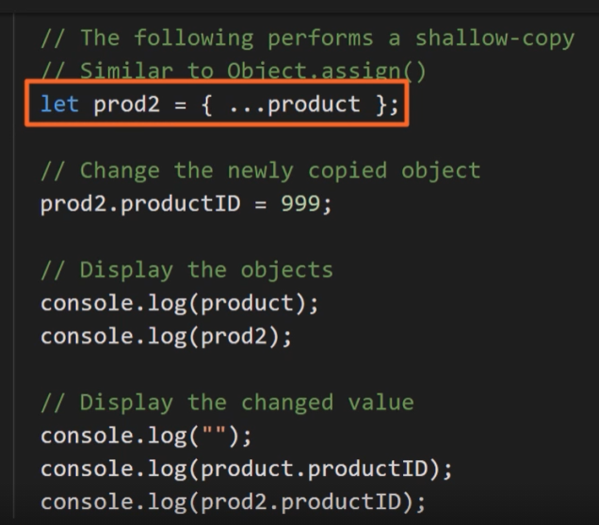

Spread can be used to copy object and modified will be only one of them.

But spread make your code hard to read.